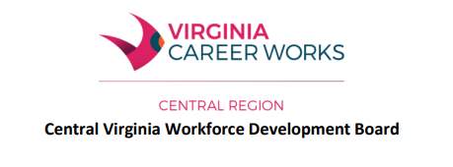
Workforce Innovation and Opportunity Act (WIOA) Program Policy #112

Subject: 5% Youth Low Income Exception
Effective Date: April 9, 2024
Revised: N/A
Policy Statement:
This policy provides guidance on when it is appropriate to use the 5% Youth Low Income Exception and who is eligible under this exception.
EXCEPTION - Not more than 5% of participants assisted under the youth program may be individuals who do not meet the low-income criteria to be considered eligible youth, where applicable if they are within one or more of the following categories:
1. School Dropout
2. Basic Skills Deficient
3. Are one or more grade levels below the grade level appropriate to the youth’s age
4. Pregnant or parenting
5. Possess one or more disabilities (including learning disabilities)
6. Homeless or runaway
7. Offender
8. Face serious barriers to employment such as:
- Is habitually truant as defined by State law.
- Has failing grades as defined by having failed a minimum of three (3) classes in most recent grading period.
- Did not pass the Literacy Passport test given in the 9th grade or the last Standard of Learning Test given.
- Has not made substantial progress in mastering skills that are appropriate for students of his/her age.
- Has poor work history for older youth (has not worked 13 consecutive weeks of thirty (30) hours or more in the last calendar year).
For a Youth to be considered under the 5% rule, the Youth Program Operator must make a formal written request to the CVWDB Executive Director. The Program Operator must receive written approval from the CVWDB Executive Director before the youth can be registered to receive program services. The Board will track and monitor the 5% Income Exception numbers quarterly.

