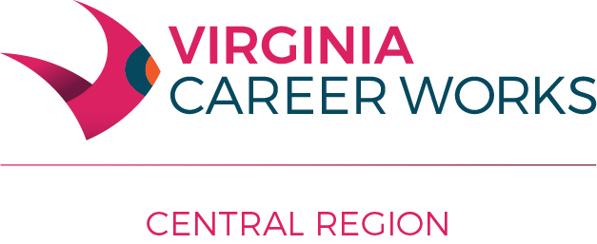
Central Virginia Workforce Development Board
Workforce Innovation and Opportunity Act (WIOA) Administrative Policy #213
Subject: Out-of-Area Job Search and Relocation
Effective Date: April 14, 2026
PURPOSE: To guide the compliance of federal regulations that allow reimbursement for Out-of-Area Job Search and Relocation for adults and dislocated workers while they are in individualized career services. This policy is set to allow those interested in leaving the area to expand their job search to other parts of the country and to help adults and/or dislocated workers with the moving expenses associated with accepting a job out of the area and the relocation expenses associated with the required move.
Out-of-Area Job Search reimbursement allowance:
Out-of-Area Job Search reimbursement may be provided to adults and/or dislocated workers who have job interviews that are scheduled to take place out of the area. The Central Virginia Workforce Development Board requires that verification from the interviewing company be received before the interview. The verification must state the position for which the interview is scheduled, the interview location, date and time to be considered under this policy.
Out-of-area job search reimbursement may be paid as follows:
- If an individual must travel more than 50 miles for an interview, only gasoline reimbursement may occur.
- If an individual must travel more than six hours to get to an interview, lodging and food reimbursement may occur in addition to gasoline reimbursement.
All Out-of-Area Job Search reimbursements will be paid only on actual receipts. This includes gasoline, food, and lodging. The Food Allowance is set at a maximum of $35.00 per day, including taxes and tips. Lodging reimbursement is at the Program Operator’s discretion.
Relocation reimbursement may be paid as follows:
Relocation reimbursement may be provided to adults and dislocated workers who have accepted positions that require them to move from their current residence in the Lynchburg region. This policy helps reimburse the cost of moving personal property from one residence to another. The Central Virginia Workforce Development Board relocation policy reimburses the cost of moving rental equipment (moving van/truck) and gasoline, but not the cost of professional movers. If the move requires an overnight stay, food and lodging may be provided, along with reimbursement for gasoline and rental equipment.
Relocation reimbursements will be paid only from actual receipts. This includes gasoline, food, lodging, and moving rental equipment. The food allowance is set at a maximum of $35.00 per day, including taxes and tip. Lodging reimbursement is at the Program Operator’s discretion. Moving van/truck reimbursement will be based on three moving equipment rental estimates (for example, from Ryder or U-Haul), with the Program Operator and the participant agreeing on the best proposal.
The Central Virginia Workforce Development Board requires that a WIOA Out-of-Area/Relocation Services Authorization form be completed and maintained in the client file for all participants who require this service.

